**Lab Exercise 4- Signed Commits in Git and GitHub**

**Objective:**  
To configure Git to sign commits with GPG, push them to GitHub, and verify commit authenticity for secure code contribution.

**Prerequisites:**

* Git installed on your system
* GPG (GNU Privacy Guard) installed and configured
* GitHub account with a repository (you own or have write access to)
* Basic knowledge of Git commands

**Step 1 – Generate or Use an Existing GPG Key**

1. **Check for existing keys**

gpg --list-secret-keys --keyid-format=long



1. **If no key exists, generate a new one**

gpg --full-generate-key

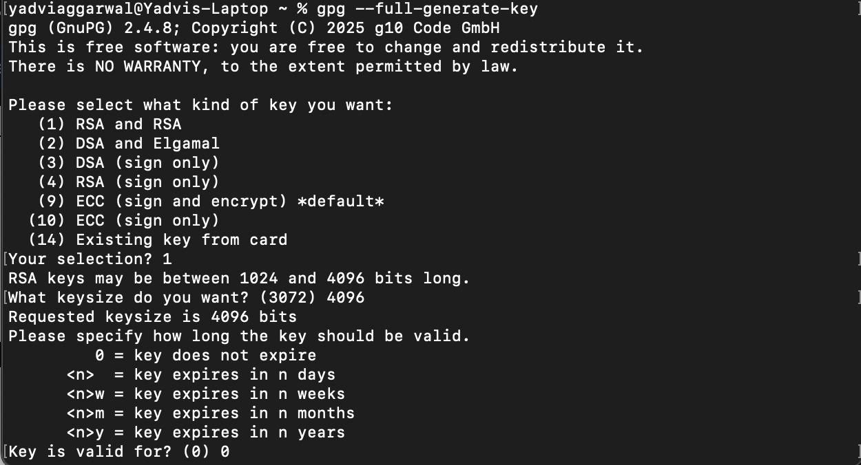

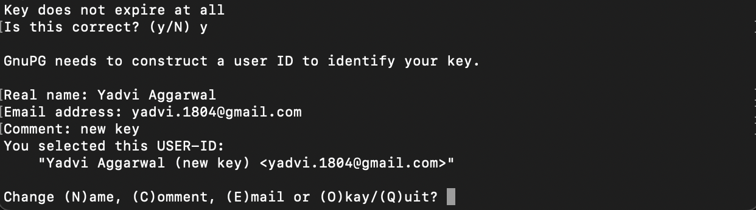

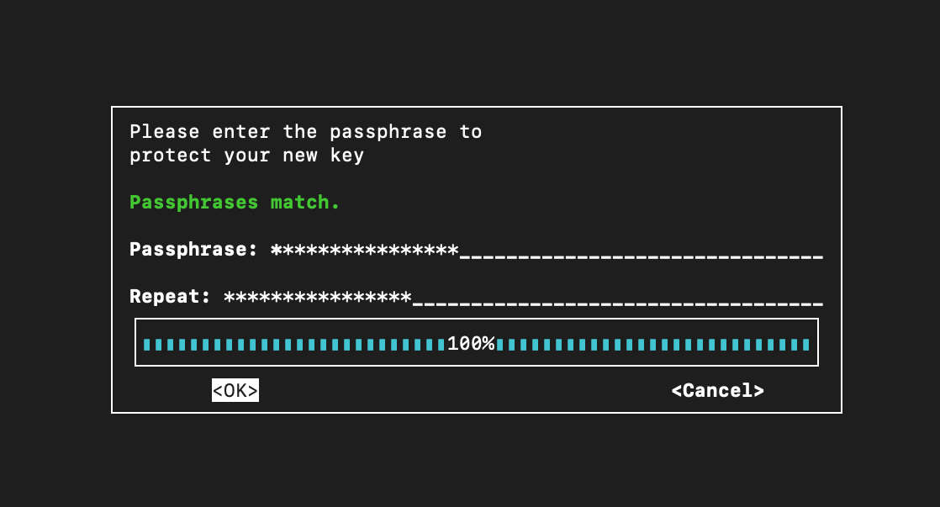

* + Select **RSA and RSA**
  + Key size: **4096**
  + Expiration: **0** (never) or a fixed date
  + Enter your **GitHub-registered name and email**

1. **Get your key ID**

gpg --list-secret-keys --keyid-format=long

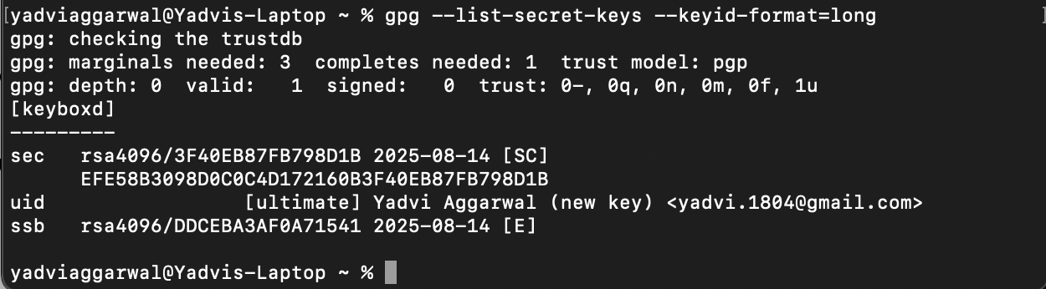

Example output:

sec rsa4096/3AA5C34371567BD2 2025-08-13 [SC]

Here, 3AA5C34371567BD2 is your key ID.

**Step 2 – Add GPG Key to GitHub**

1. Export your public key:

gpg --armor --export YOUR_KEY_ID

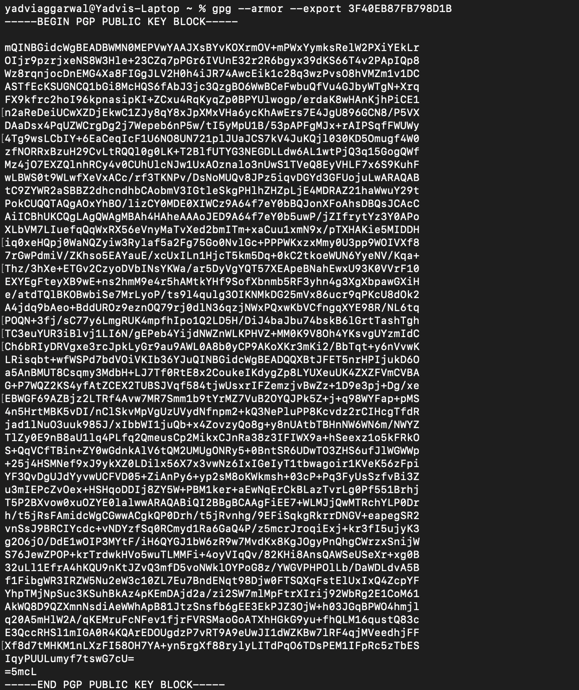

1. Copy the output.
2. Go to **GitHub → Settings → SSH and GPG Keys → New GPG Key**.
3. Paste your key and save.

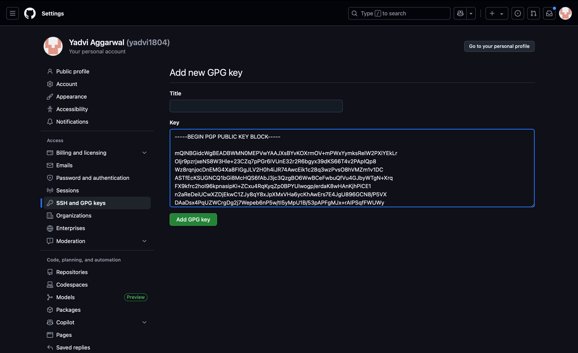

**Step 3 – Configure Git for Signed Commits**

1. Tell Git which key to use:

git config --global user.signingkey YOUR_KEY_ID

1. Enable signing for all commits:

git config --global commit.gpgsign true



**Step 4 – Make a Signed Commit**

1. Clone your repo (or use an existing one):

git clone https://github.com/<username>/<repository>.git

cd <repository>

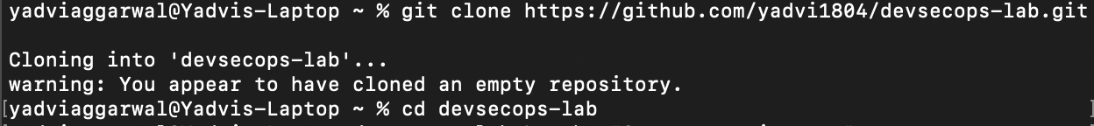

1. Edit or create a file:

echo "Secure commit test" >> secure.txt

git add secure.txt



1. Commit with signing:

git commit -S -m "Add secure commit test file"

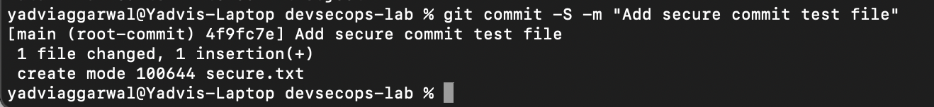

1. Enter your GPG passphrase when prompted.

**Step 5 – Push and Verify on GitHub**

1. Push the commit:

git push origin main

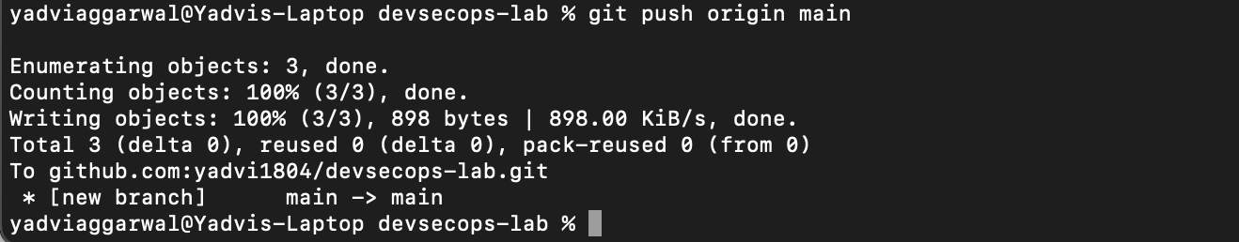

1. Go to your repository on GitHub → Click the commit → You should see a **green “Verified” badge**.
2. 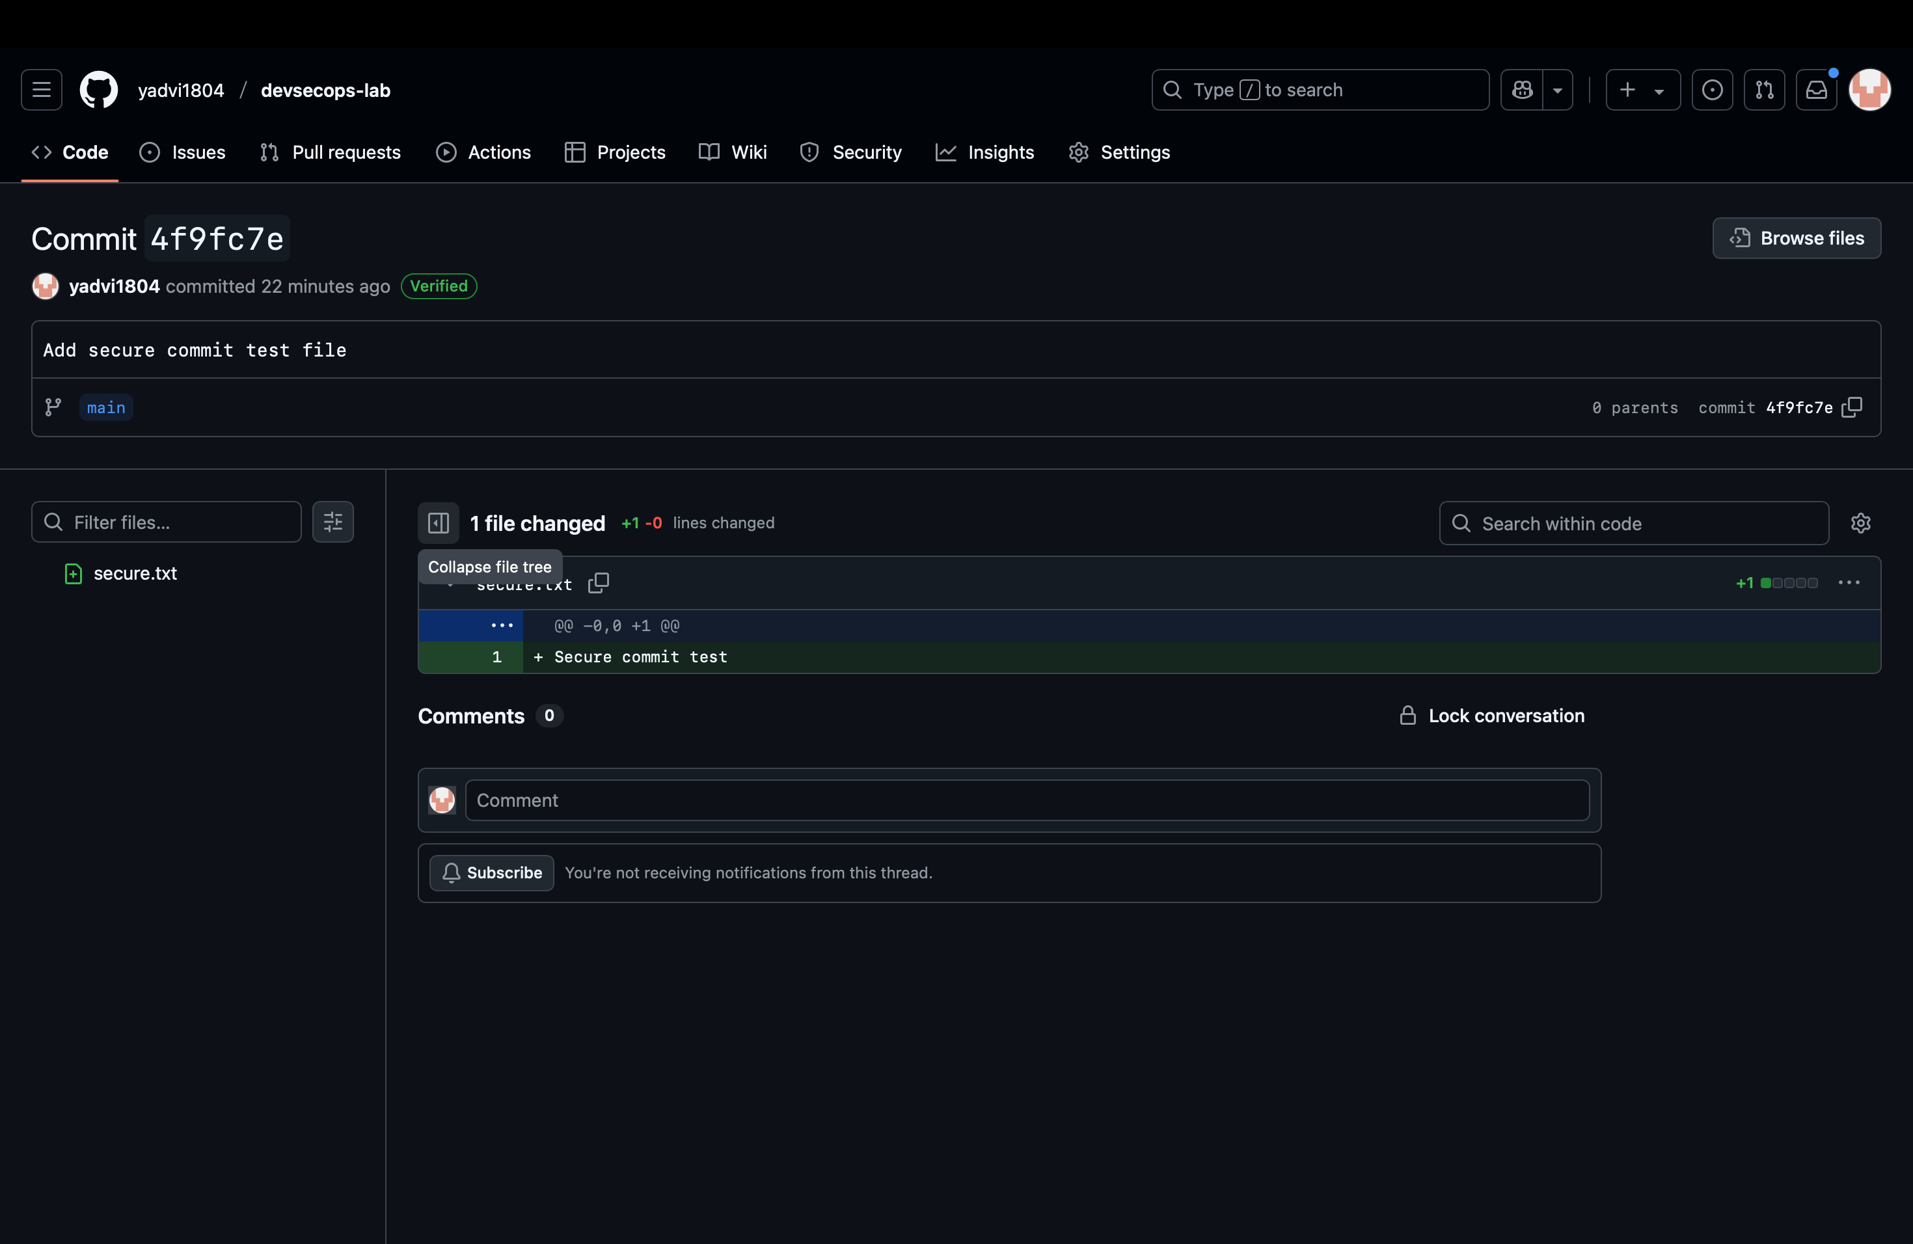

**Step 6 – Local Verification of Commit**

git log --show-signature

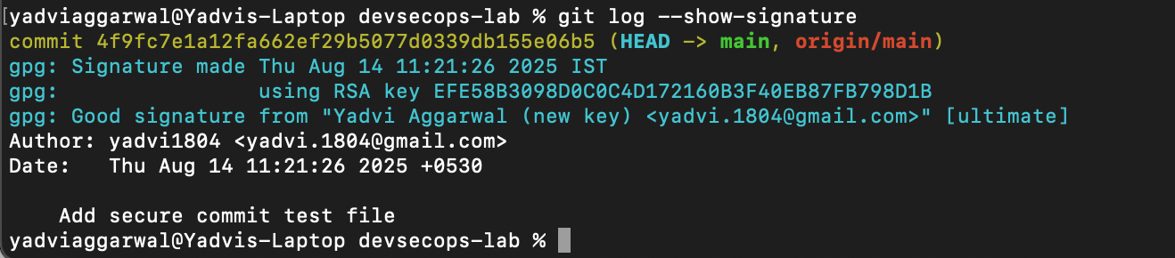

This will display the GPG verification details locally.

**Use Case**

Signed commits prevent identity spoofing in collaborative projects, ensuring only verified authors can make trusted changes in critical codebases.